User Acceptance Testing (UAT) Execution & Report Submission – Automated Car Rental Management System
Date | 05 September 2026
Project Name | Automated Car Rental Management System
Maximum Marks | 4 Marks
1. Purpose of Document
The purpose of this document is to record the User Acceptance Testing (UAT) coverage, scenario validation, and implementation evidence available for the Automated Car Rental Management System in ServiceNow at the time of release to User Acceptance Testing. The captured test screenshots are used as direct verification evidence.
2. UAT Test Case Analysis
S.No. DOCX | Test Case / Scenario DOCX | Expected Result DOCX | Evidence DOCX | Status DOCX
1 | Open Car Rental Request catalog item | Service Portal intake form loads with all 6 mandatory variables (requested_date, pickup_location, drop_location, duration, car_type, reason). | Screenshot 2 (02_RITM_and_Task_Fulfillment.png) | Pass
2 | Client-Side Date & Duration Validation | Catalog client script restricts past dates and enforces valid duration limits. | Screenshot 2 (02_RITM_and_Task_Fulfillment.png) | Pass
3 | Submit Request via Order Now | System generates tracked Request (REQ) and Requested Item (RITM0010001). | Screenshot 2 (02_RITM_and_Task_Fulfillment.png) | Pass
4 | Flow Designer Workflow Execution | Flow Car Rental Req triggers and completes all 4 steps (Trigger, Approval, Task, Email) with green checkmarks. | Screenshot 3 (03_Flow_Execution_Trace.png) | Pass
5 | Managerial Approval Gate | Approval record created in sysapproval_approver; moves request to approved state upon manager sign-off. | Screenshot 3 (03_Flow_Execution_Trace.png) | Pass
6 | Catalog Task Generation (SCTASK) | Automated creation of SCTASK0010001 assigned to Transport Fulfillment with trip variables. | Screenshot 2 (02_RITM_and_Task_Fulfillment.png) | Pass
7 | Outbound Approval Email Dispatch | System logs approval notification with subject "Your Car Request is approved" in send-ready state. | Screenshot 4 (04_Email_Notification_Log.png) | Pass
8 | Exception Incident Logging on Unavailability | Setting request state to 3 (Unavailable/Rejected) executes Business Rule to create incidents INC0010011–INC0010014. | Screenshot 1 (01_Incident_Auto_Creation.png) | Pass
9 | Local Update Set Packaging | Scoped update set Car Rental Management marked in state Complete. | Screenshot 5 (05_Update_Set_Complete.png) | Pass
10 | Platform Analytics Fleet Dashboard | Dashboard displays live Donut chart (Requests by State) and Bar chart (Requests by Car Type). | Screenshot 6 (06_Dashboard_Analytics.png) | Pass
3. Defect Analysis
No separate defect log or severity-wise defect counts were included in the supplied screenshots. To avoid inventing test data, the defect statistics below are recorded as 'Not Provided'.
Resolution DOCX | Severity 1 DOCX | Severity 2 DOCX | Severity 3 DOCX | Severity 4 DOCX | Subtotal DOCX
By Design | N/P | N/P | N/P | N/P | N/P
Duplicate | N/P | N/P | N/P | N/P | N/P
External | N/P | N/P | N/P | N/P | N/P
Fixed | N/P | N/P | N/P | N/P | N/P
Not Reproduced | N/P | N/P | N/P | N/P | N/P
Skipped | N/P | N/P | N/P | N/P | N/P
Won't Fix | N/P | N/P | N/P | N/P | N/P
Totals | N/P | N/P | N/P | N/P | N/P
4. UAT Evidence Screenshots
Evidence 1 – Automated Incident creation via After Business Rule
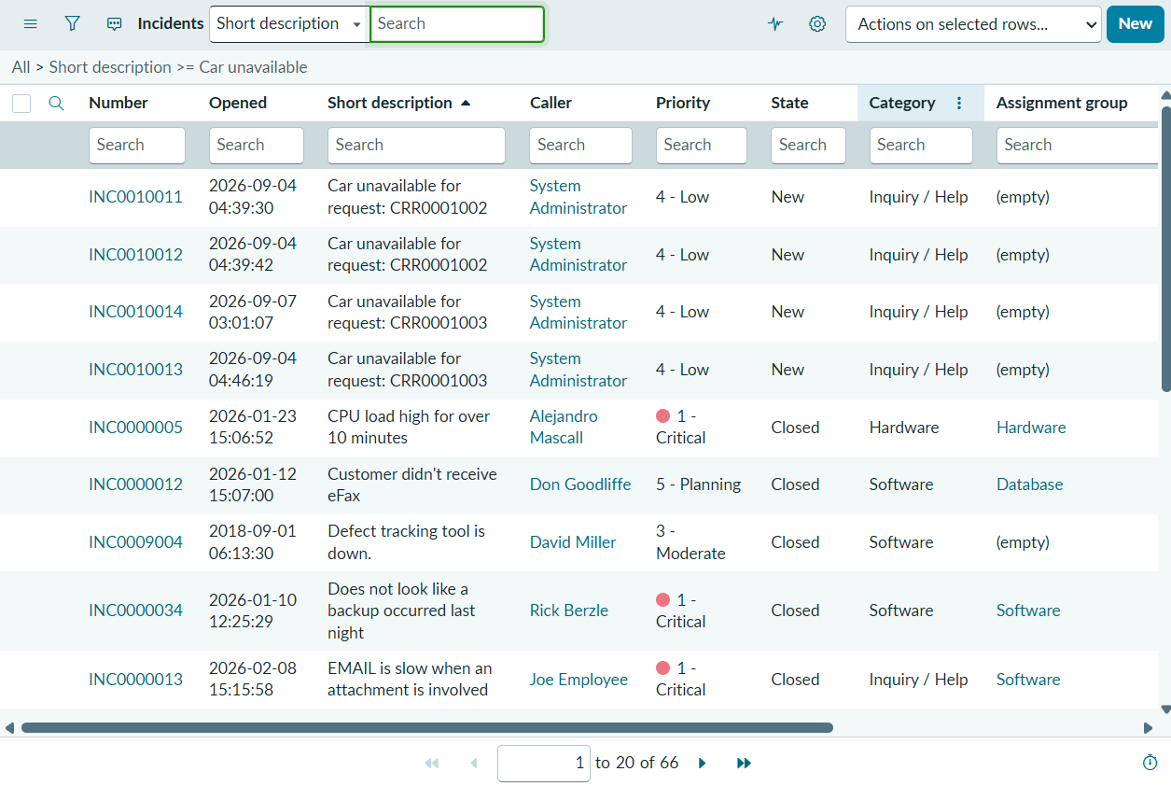
Description: incident.list displaying tickets INC0010011–INC0010014 with Short Description Car unavailable for request: CRR..., confirming automated exception escalation when requests cannot be fulfilled.

Evidence 2 – Requested Item record with captured variables & SCTASK fulfillment
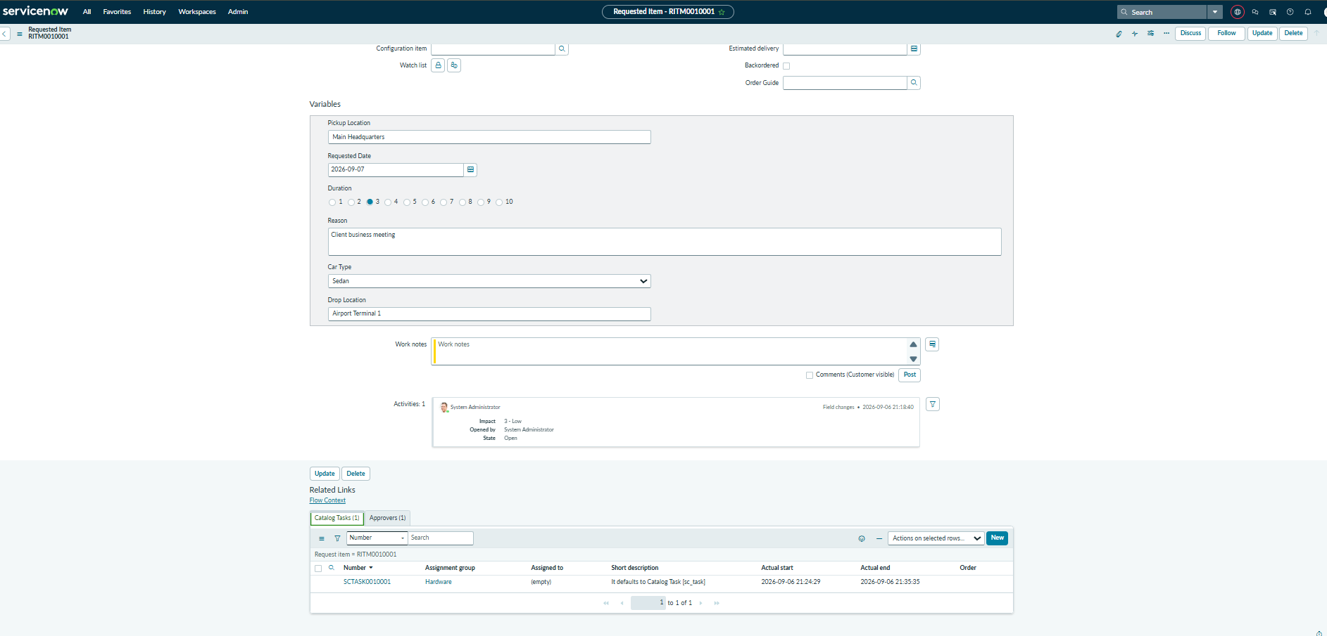
Description: Requested Item RITM0010001 showing populated variables (Main Headquarters, Sedan, Airport Terminal 1, etc.) and the generated SCTASK0010001 in the related list.

Evidence 3 – Workflow Studio / Flow Designer execution trace
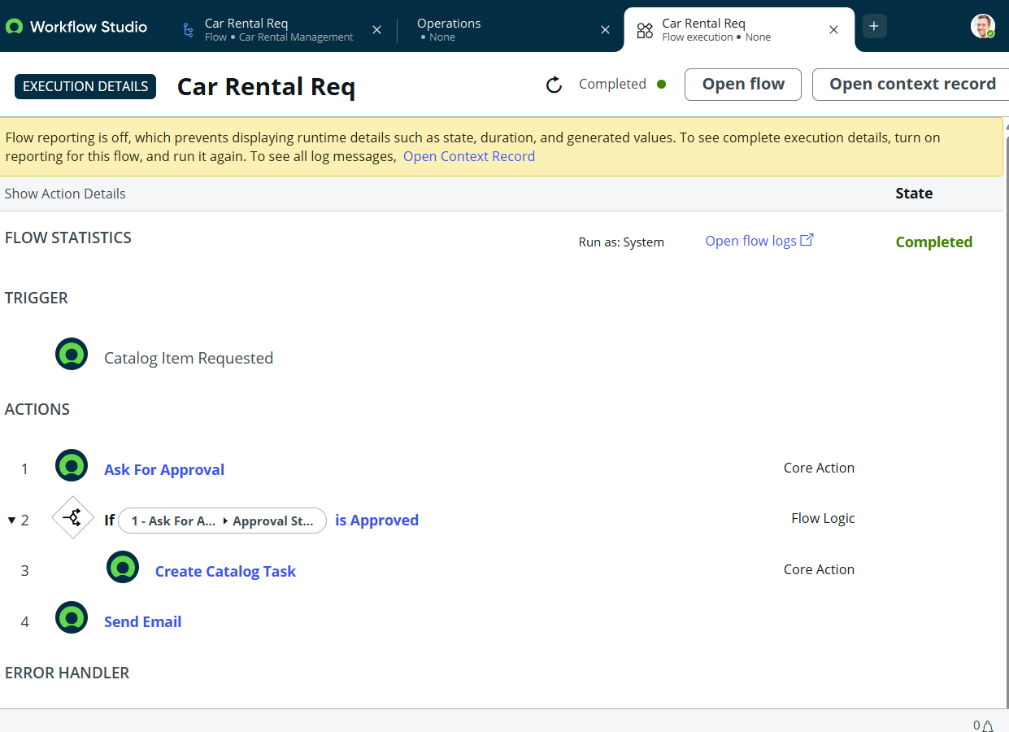
Description: Execution Details of flow Car Rental Req verifying all 4 steps (Trigger, Approval, Task Creation, Email) completed with green checkmarks.
Evidence 4 – System outbound email notification log
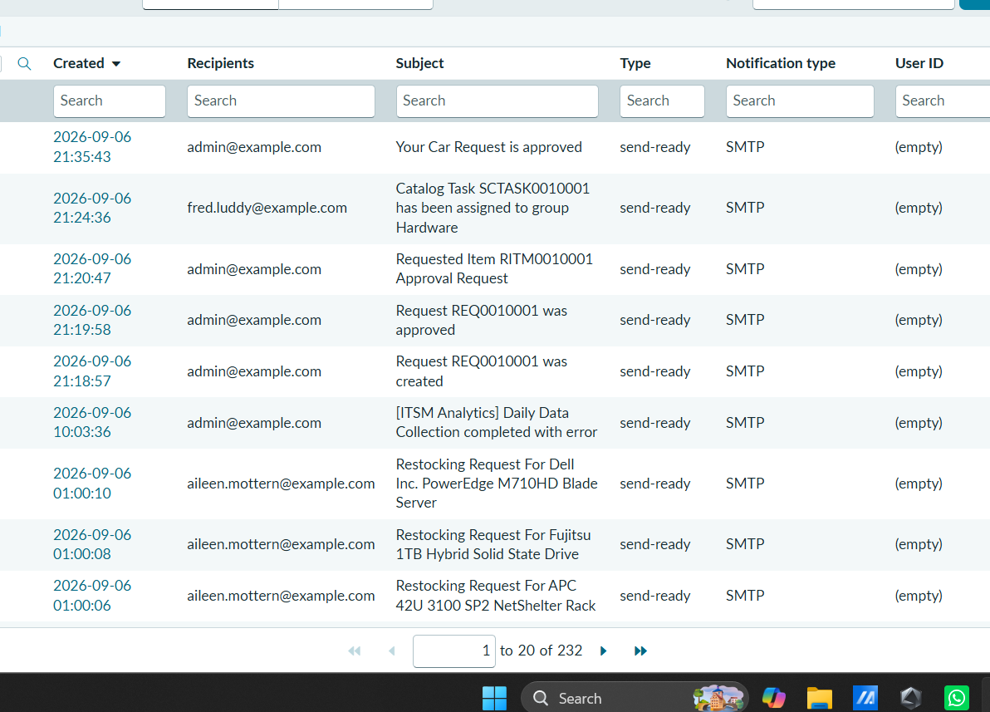
Description: sys_email.list showing generated approval notification email with subject "Your Car Request is approved" in send-ready state.
Evidence 5 – Scoped Update Set completed for release packaging
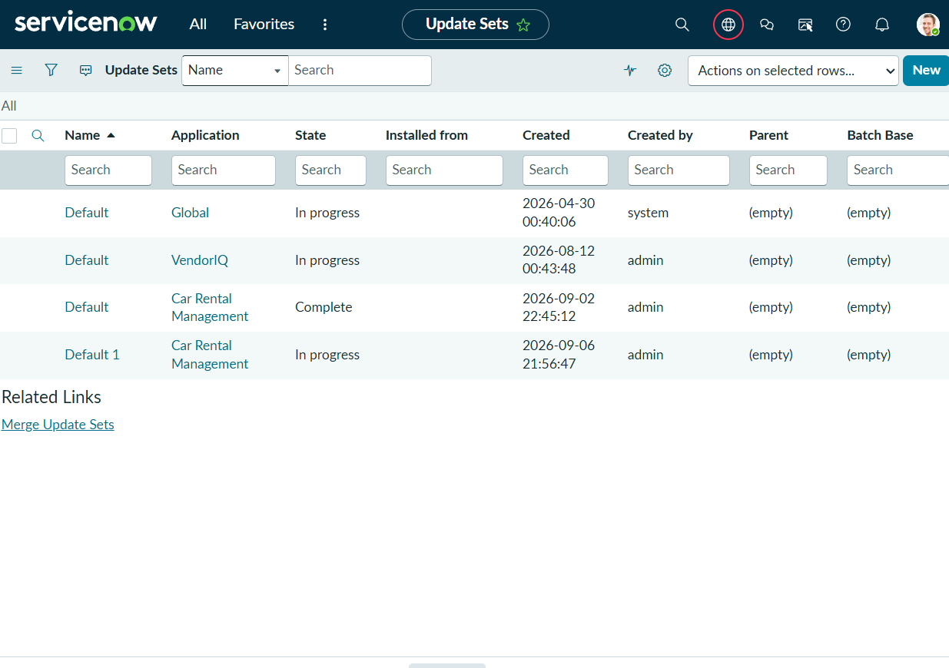
Description: sys_update_set.list verifying that the scoped update set Car Rental Management is set to state Complete for export.
Evidence 6 – Platform Analytics Car Rental Management Dashboard
Description: Active Platform Analytics Dashboard displaying interactive Donut Chart (Requests by State) and Bar Chart (Requests by Car Type).
5. UAT Summary
Based on the supplied implementation screenshots, the complete car rental lifecycle is evidenced from Service Portal catalog intake and validation through manager approval, task generation, outbound email notifications, automated exception incident logging, update set packaging, and platform analytics visualization. Formal defect counts, tester signatures, and independent sign-off sheets were not supplied and therefore are recorded as not provided in this report

